Military, Veterans and Families Education Summit

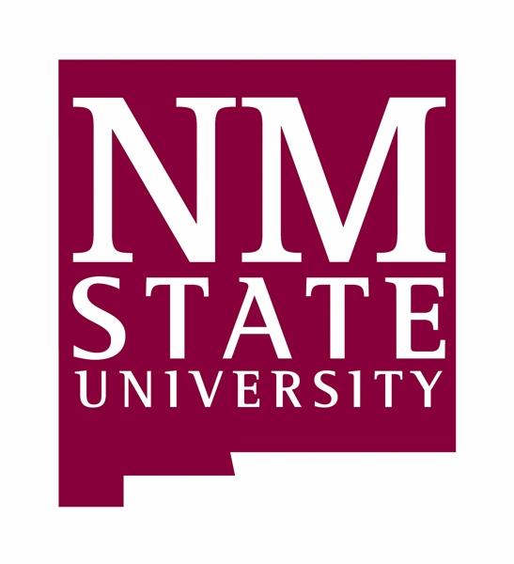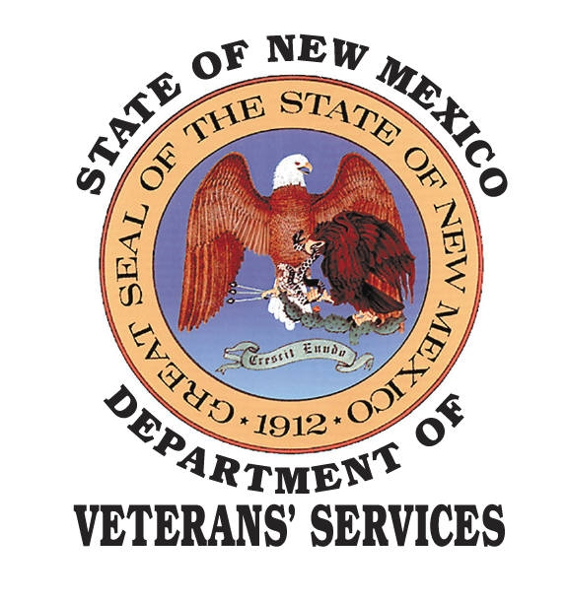

Summary

Transformation: Forming Tomorrow’s Leaders Today, Anywhere, Anytime

Hosted by

New Mexico State University
College of Extended Learning
and
Department of Veterans’ Services
State of New Mexico

New Mexico State University
Las Cruces, New Mexico

October 21-22, 2008
New Mexico State University
Las Cruces, New Mexico USA
October 21-22, 2008
Summary of the Military, Veterans and Family Education Summit College of Extended Learning - Military Program
HOSTED BY
New Mexico State University
College of Extended Learning, All Things Military Program
and
Department of Veterans’ Services, State of New Mexico
New Mexico State University, College of Extended Learning
Dr. Carmen Gonzales
Vice President for Student Success
Dean of the College of Extended Learning
Dr. Roberta Derlin
Associate Vice President for Student Success
Associate Dean of the College of Extended Learning
Dr. Fred J. Rodíguez
Military Coordinator for Student Success
Department of Veterans’ Services
Cabinet Secretary John C. Garcia
Department of Veterans’ Services
State of New Mexico
Deputy Cabinet Secretary Lou Helwig
Department of Veterans’ Services
State of New Mexico
Military, Veterans and Families Education Summit
Summary
Fred J. Rodríguez, Ph.D.
Summit Director
All Things Military (ATM) Planning Committee
Roberta Derlin, Ph.D.
Lee Hamilton, Ph.D.
Laura Grant
David Melendez
October 21- 22, 2008
Introduction
The Military, Veterans and Families Education Summit was an exciting and extremely enjoyable event filled with memorable moments. Some 200 participants attended and were welcomed immediately by a sense of exhilaration as all the delegates began to explore the challenges of meeting the post-secondary needs of the expanding military communities. The atmosphere of energy highlighted the conference theme " Transformation: Forming Tomorrow’s Leaders Today, Anywhere, Anytime." and emphasized that we must all look out for each other and champion each other's successes. The goal of the seminar was to bring together legislative leaders, state and federal agencies, and academic and military leader to address these educational opportunities.
What Happened at the Summit?
Beginning the day with distinction was the introduction of dignitaries by Dr. Carmen Gonzales, Vice President for Student Success and Dean of the College of Extended Learning. NMSU’s Provost, Dr. Robert Moulton, discussed the great educational opportunities at NMSU and the chance to strengthen the NMSU and military partnership through this leadership summit. President Waded Cruzado welcomed the delegates and expressed her enthusiasm for the military and educational communities’ collaboration. Senator Jeff Bingaman’s endorsement was read by Michael Yudin, the Senator’s representative from Washington, D.C.
The general opening session included presentations by Colonel John G. Rossi, the Deputy Commanding General and Chief of Staff, U.S. Army Air Defense Center at Fort Bliss and Major General Kenny C. Montoya, the Adjutant General of the New Mexico Army and Air National Guard. Colonel Rossi mentioned the rapid growth at Fort Bliss and the challenges of transformation the command faces. He also talked about a diverse military community with an intellectual curiosity, understanding the educational demands for soldiers and families, and sensitivity to military families, who over the course of a career, may move as many as fifteen times. Major General Montoya described the role of the citizen soldiers and airmen in a global community.
In the following session Dr. Frank Mayadas, Sloan Foundation, addressed “The Changing Face of Education: Distance Education, the Military and Leadership.” He also gave a chronological summary of distance learning, past, present and future.
The Lunch Session began with a keynote address on veterans’ educational opportunities by Deputy Secretary Lou Helwig, Department of Veterans’ Services, State of New Mexico. He stated that there are “nearly 180,000 veterans in New Mexico…Only about 3,500 are currently enrolled in New Mexico’s universities, community colleges or vocational schools…That’s about 2 percent of New Mexico’s veterans continuing their education…That’s far too low…This summit is an excellent opportunity for veterans to meet the NMSU faculty and see what’s available for them.”
After lunch, an enlightening Panel Session included Colonel Gary Giebel, Garrison Commander at White Sands Missile Range, Colonel Ed Manning, Garrison Commander at Fort Bliss, Colonel Stephen DiFonzo from the 49th Fighter Wing at Holloman AFB, Colonel Don Gentry, Commandant of the U.S. Sergeants Major Academy and Colonel John Mayer from Joint Task Force at Fort Bliss.
COL Giebel said support for military personnel is critical, and more colleges, universities and the communities they’re in need to be more like NMSU and Las Cruces. COL Manning highlighted community building and the signing of a “Community Covenant” between Fort Bliss and NMSU. COL Gentry stated that “Soldiers are going after college degrees in many, many areas,”...Their desire for education is insatiable.” COL DiFonzo described the College of the Air Force and the opportunity for NMSU to partner with CCAF. COL Mayer outlined the trends in military higher education that he saw as potential shapers of military collegiate instruction in the future.
Two breakout sessions rounded out the day’s academic activities. J.R. Turner and Virginia Bell from the Las Cruces Veterans’ Services Office spoke about vocational, rehabilitation and education initiatives. Michele Spires from the American Council of Education presented the evaluation of educational experience in the Armed Services (see Appendix A).
The roundtable discussions throughout the conference sparked a lively dialogue among the participants on a variety of relevant topics, with input from an NMSU faculty member serving as the table host. Table hosts, under the leadership of Dr. Lee Hamilton, met members of the Board of Regents, senior military commanders from local military installations, their spouses, and representatives of the New Mexico Department of Veterans’ Services, members of central administration, and college deans. Table hosts listened, posed questions, and created a list of responses on how best to strengthen the partnership between NMSU and our military communities (see Appendix B).
NMSU student ambassadors from the College of Health and Social Services gathered and documented the conclusions from each table. As one participant stated, "Something powerful happened here today. Leadership in action and working with our faculty was inspiring,” said a young ambassador.
Army and Air Force ROTC cadets played a crucial role in the planning and implementation of the conference by presenting the colors, singing the national anthem, meeting and escorting dignitaries and registration. NMSU’s colleges displayed their academic programs. All are to be congratulated for their fantastic work, leadership, and dedication!
Delegates agreed that this conference had filled them with a belief in themselves and in their colleagues. More importantly, they came away with a better understanding of NMSU’s initiative of becoming a military friendly university. "Synergism, free thought, the need to take action, and passion" were phrases used to describe the experience. As one scholar stated "I am genuinely proud to be a part of the 'NMSU World'."
An article entitled: College of Extended Learning summit in October to foster military-friendly university, written by Audry Olmstead, certainly captured how the successful forum held in June at Fort Bliss would lead the way for a larger and more comprehensive event (see Appendix C). The article, NMSU hosts military education summit, written by Steve Ramirez, Sun-News, highlighted the summit theme when he said “A well-trained American military is well educated, and those two factors can happen with continued assistance by New Mexico State University” (see Appendix D).
Strengthening of the NMSU - Military Relationship
Empowerment is a very comprehensive, dynamic process that has the potential to substantially impact an organization and groups of individuals. Inherent and vital in the process, however, is the inclusion of trust and establishing collaborative partnerships with a group of leaders in order for the empowerment process to be effective. This is specifically what happened at the Military, Veterans and Families Education Summit. The adoption of trust in and among the delegates was central to their willingness to present their ideas, thoughts and outlook in a collegial, dynamic arena to explore the challenges of meeting the post-secondary needs of the expanding military communities. The atmosphere of energy highlighted the conference theme " Transformation: Forming Tomorrow’s Leaders Today, Anywhere, Anytime."
From the moment the military guests arrived one couldn’t help but note that NMSU’s faculty and staff had a great responsibility--a responsibility of developing a collaborative partnership with our regional military communities. We should all be proud of the collaborative efforts being put forth by the NMSU community.
Tracking Other Military Friendly Accomplishments
Military and Community Leaders Conversation: A special group of prominent local businesswomen and civic leaders gathered for the Military and Community Leaders Conversation, to focus on building community across military and civilian sectors. Their sharing ideas and resources brought home the concept of collaborative arrangements through fund raising initiatives to benefit our wounded warriors (see Appendix E).
Professional Development ACE Seminar: As part of the Military, Veterans and Families Education Summit a special seminar by Michele Spires, American Council on Education, was held the day before (see Appendix F). This seminar on evaluating military transcripts was targeted to academic advisors, faculty, career counselors, and enrollment management personnel. Advisors learned how to assign college credits for military courses and experiences to ensure the integrity of the review process. Approximately 40 participants attended the seminar.
The attendees agreed that this special seminar had filled them with a belief in themselves and their ability to properly advise their students (see Appendix E). Some of their comments follow: “if you want to do right by your students/advisees, you must take this workshop”…”bring the speaker for a faculty senate presentation.” Another participant stressed that the concepts presented were “highly valuable from a “One-University” perspective that stakeholders - advisors, admissions, and registrar personnel - are on the “same sheet of music!...academic rigor of evaluation process equals confidence”…”to honor and support the sacrifices and service to our country of our military men and women, we must recognize and properly award deserved credit for military education and experience. Come, join us” Others stated “need to put together standard guidelines…must now move to establish university policy for the evaluation of ACE transcripts…policies need to be followed…academic advisors, registrar and admissions will become more proficient in the evaluation of military/ACE transcripts…and by doing so NMSU becomes more of a military friendly university…”
A Partnership Success Story
One of the most outstanding examples of community building was the Military, Veterans and Families Education Summit. It started when New Mexico State University and the regional military communities at Fort Bliss, White Sands Missile Range and Holloman AFB partnered to work toward a common educational vision. This community building initiative was strengthened when New Mexico’s Department of Veterans’ Services and the New Mexico National Guard joined these collaborative arrangements. During the initial planning meetings with these organizations, it was our dream to first visualize what we wanted and then act to get there. Our challenge was to take that idea, communicate it to the entire military and civilian communities, and work together to make that vision a reality. That vision radiated throughout the south-north corridor of the southwest U.S., extending all the way from El Paso up I-10/I-25 to Santa Fe. The summit endorsements further illustrated the positive impact this educational gathering provided (see Appendix G).
Concomitantly, the Military, Veterans and Families Education Summit served as a catalyst to further action of the American Council on Education (ACE) broad-based initiative aimed at facilitating a seamless transition from the battlefield to the classroom. Specific areas of focus include:

- Expanding the educational awareness of educational opportunities for active duty servicemembers, veterans and families.
- Calling public attention to the new GI Bill and higher education’s engagement in serving those who serve.
- Supporting colleges and universities in developing programs designed to increase access and success for military veterans.
- Implementing an outreach strategy to inform military veterans of their education benefits and to assist in their college planning.
- Establishing a model to assist other colleges and universities in extending educational opportunities to our military and families.

At Appendix H are listed individuals who contributed to the success of the Summit. We applaud their commitment to the overall education of our military and veterans, family members, Department of the Army Civilians, National Guard and Reservists. As we all know, in order to flourish as individuals as well as a global society, we must foster the uniqueness and interests of every student while providing them with a broad, universal education. The great work produced from this Summit will not only go on to serve our military students enrolled at NMSU, but also our military around the world.

Appendixes
Appendix A Military, Veterans and Families Education Summit Program
Appendix B Delegates’ Recommendations
Appendix C Press Release, Audry Olmstead, University Communication
Appendix D Press Release David Ramirez, Sun-News Las Cruces
Appendix E Military and Community Leaders Conversation
Appendix F American Council on Education Seminar
Appendix G Endorsements
Appendix H Contributors
General Dwight David Eisenhower wrote that the qualities of a great person are “Vision, integrity, courage, understanding, the power of articulation, and profundity of character.”
He believed that the qualities of goodness in a person include a broad sympathy for the human condition; an awareness of human weaknesses and shortcomings and a willingness to forgive them, a sense of responsibility toward others, a genuine modesty combined with a justified self-confidence, a sense of humor, and most of all a love of life and of people.

